FORM-XV

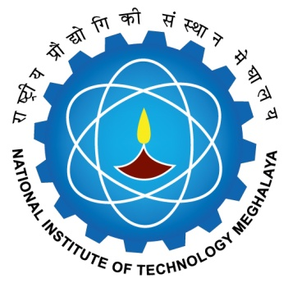

NATIONAL INSTITUTE OF TECHNOLOGY MEGHALAYA
बिजनी कॉम्‍पलेक्‍स, लैटमुख्‍्राह, शिलांग Bijni Complex, Laitumkhrah, Shillong-793003

REPORT OF EXAMINERS OF ORAL DEFENCE EVALUATION COMMITTEE
The examiners of Oral Defence Evaluation Committee (ODEC) certify that the thesis entitled _____________________________________________________________________________________________________________________________________________________________________________________submitted by __________________________________ to the NIT Meghalaya in partial fulfillment of requirement of the Ph. D. degree in the discipline of _______________________________________________________ has been examined by us and we recommend that that the degree be awarded/ we recommend that the candidate be examined further on another date not later than________ / the candidate has not performed to our satisfaction and does not deserve the degree of Ph. D.

Sl.No | Name | Signature of ODEC Member(s)
1
2
3
4
5
6
7
8
Date:
Signature of DRC Chairman
Forwarded to Dean(AA)
Remarks by Dean (AA)

Dean (AA)

Approval for Provisional certificate

Director

