IMPORTANT INSTRUCTIONS FOR PRELIMINARY TESTFOR CANDIDATES
1. Candidates are advised to download this instruction document, read them carefully and follow the instructions strictly.
2. Examination will be held in the online (internet based) mode through Google Classroom Platform.
3. Candidates can appear in the online test from their respective location(s) on their laptops, personal computers etc.
4. Candidates have to ensure uninterrupted power supply and stable internet connectivity, during the period of the test. NIT Meghalaya will not be responsible for power failure, internet failure or slow internet connectivity during the Examination days at the candidates’ end.
5. Candidates are required to report for the test and login the Google Classroom atleast 15 minutes before the commencement of the Test/Exam as per the following schedule.
Post | Date | Scheduled Time
Technical Assistant (TA) | 14 September 2021 | 11 AM to 12:40 PM
Lab Attendant (LA) | 14 September 2021 | 3 PM to 4:40 PM
Technician (TE) | 15 September 2021 | 11 AM to 12:40 PM

The question paper will be uploaded in the Google Classroom 5 minutes before the scheduled time.
The candidate must SUBMIT his/her final response by the end of the scheduled time, failing which his/her response will not be recorded at NIT Meghalaya and will be considered as NOT SUBMITTED in the Test. The Invigilator(s) from NIT Meghalaya will post the time reminders in the Google Classroom.
6. The candidate must log in the Google Classroom using the Gmail ID provided by him/her in the Google Form as per the instructions given vide notification Ref. No. NITMGH/ES/REC/N-F/Vol.IV /2021-22/510 dated 19.08.2021.
7. The Preliminary Test/Exam will consist of 90 (ninety) Multiple-Choice Questions to be answered in 100 (one hundred) minutes. Correct answers will be awarded 3 (three) marks. There will be 1 (one) negative mark for every wrong answer. Unanswered questions will not carry any marks, i.e. Zero mark.
8. Candidates must click on the final SUBMIT button for the successful submission of their response.
9. If at any stage, it is found that the candidate has submitted multiple responses, his/her candidature will be cancelled.
10. Candidate should not adopt any unfair means or indulge in any unfair practice.
11. Candidates are advised to go through the Instructions on “How to appear in the online Test / exam through Google Classroom” carefully and be guided accordingly.

How to appear in the online Test / Exam through Google Classroom

This document is a user guide/manual for only demonstration purpose which will provide the candidates with the basic information and necessary steps to join the Google Classroom and appear for Preliminary Test/Exam for the recruitment of Non-Faculty Positions at NIT Meghalaya. The headings of this user guide/manual may change during actual examination.
Kindly go through the following steps which will be helpful for appearing in the Preliminary Test/Exam as per the schedule mentioned at page 1 of this document.

Important Note: The candidates must not refresh the web page during the examination. This will cause the permanent loss of candidates’ responses which they have made during the exam. Candidates are advised to only use Next or Back Tabs given on the bottom of each page of the Google Form for the Preliminary Test / Exam to navigate to different pages/sections.

Step 1 : Open Your Internet Browser (Preferably Google Chrome).

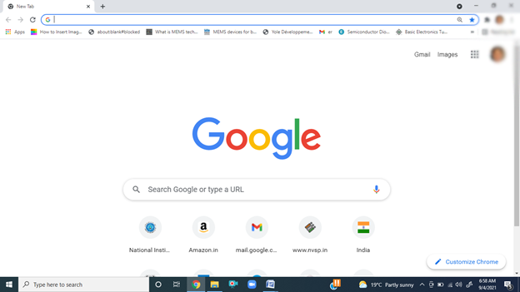

Step 2 : First of all Sign Out all your Gmail account and Log in the Gmail Account using your Gmail ID provided to NIT Meghalaya.
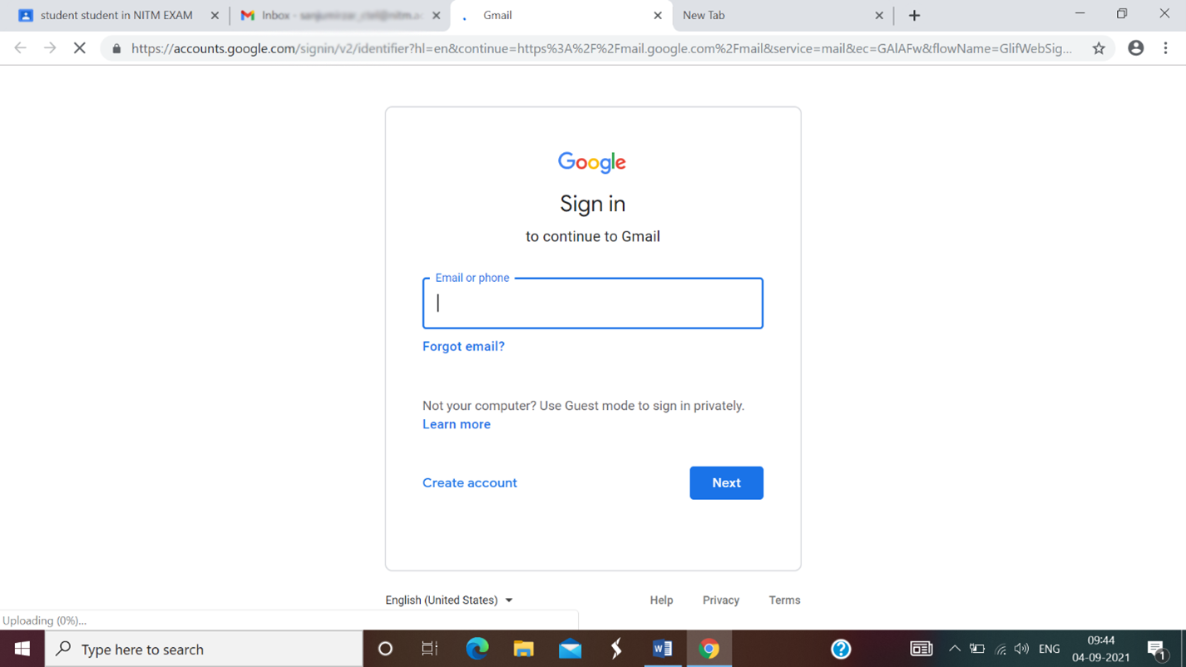

Step 3 : Candidate must accept the invitation email from Invigilator of NIT Meghalaya to join Google Classroom which will be sent to him/her tentatively on 10 September 2021. Candidate must accept the invitation for joining Google Classroom by 5 PM on 12 September 2021. If unable to join the Google Classroom, please contact the sender of the invitation email on or before 5 PM on 13 September 2021.
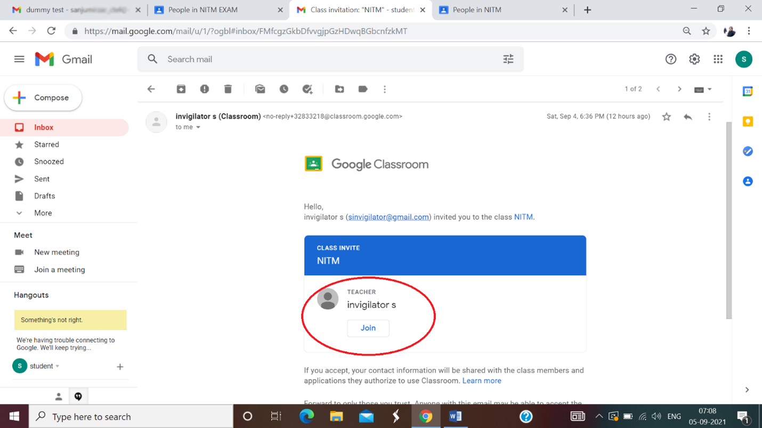
Sample of Invigilator Email ID

Step 4 : After log in into the Gmail account, Click on the Google Apps icon on the top right side of the window as shown by the red colored circle in the image below.
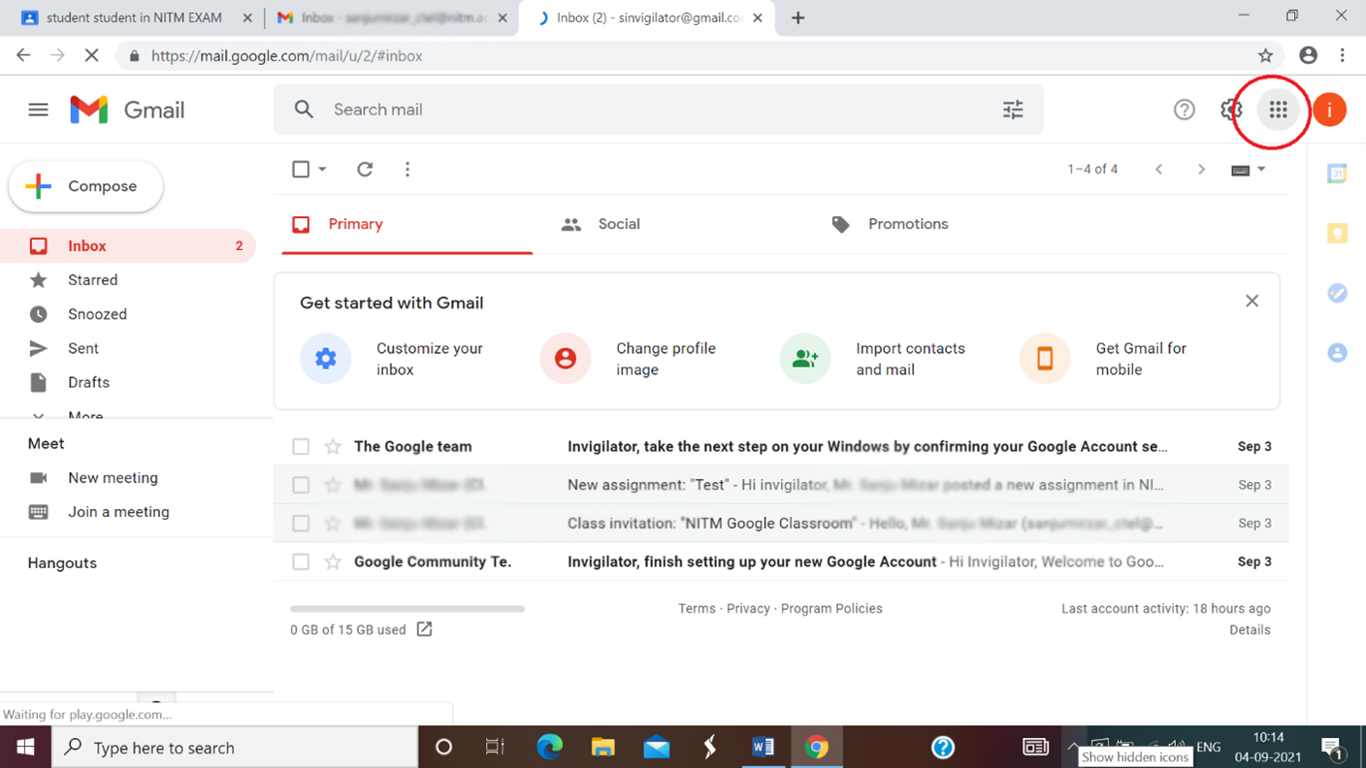

Step 5 : Click on the Classroom icon from various options available on the Google Apps window as shown by the red colored circle in the image below or go to https://classroom.google.com page. You will be then navigated to the Google Classroom page.
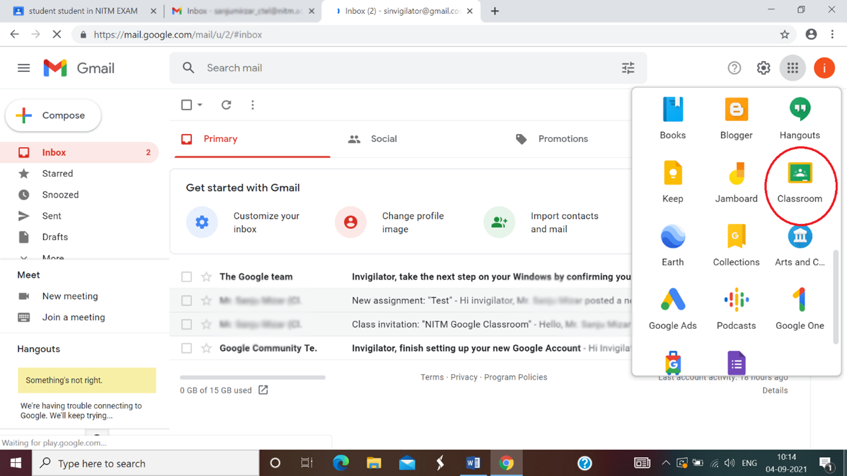

Step 6 : On the Google Classroom page, Click on the Classwork option as shown by the red colored circle in the image below.

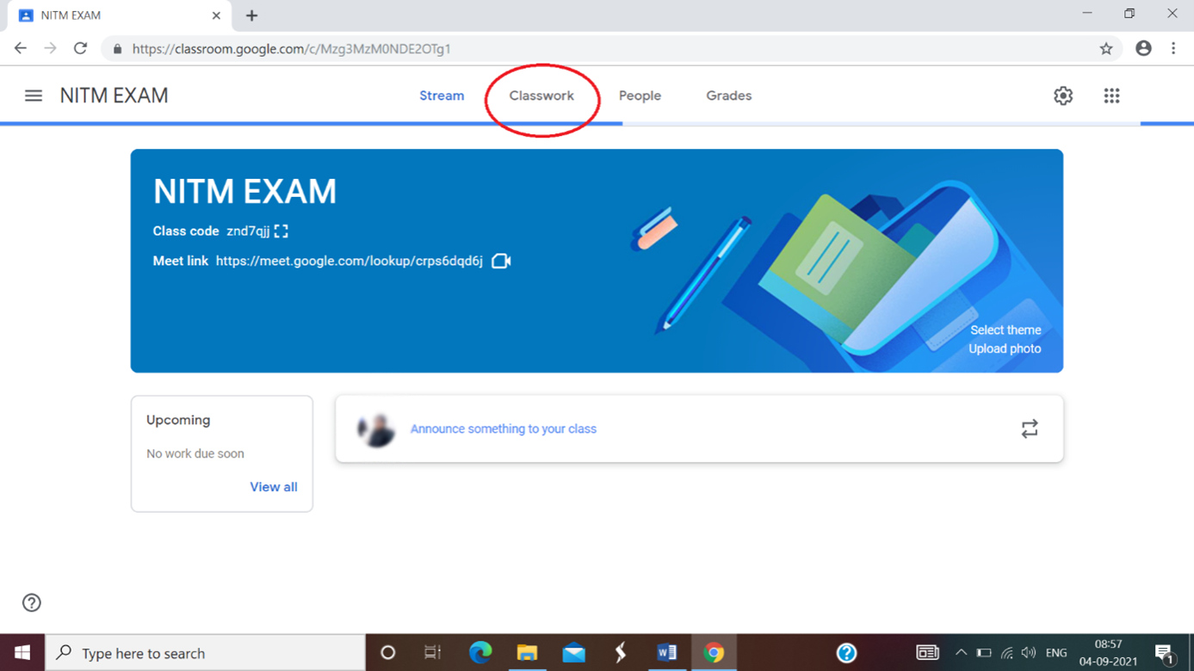

Step 7 : Click on Preliminary Test tab and then Click on the Examination Link as shown as an example on Preliminary Test 2021 by the red colored circle in the image below. This will navigate you to Google Form page for the Test / Exam in the new tab of your browser.
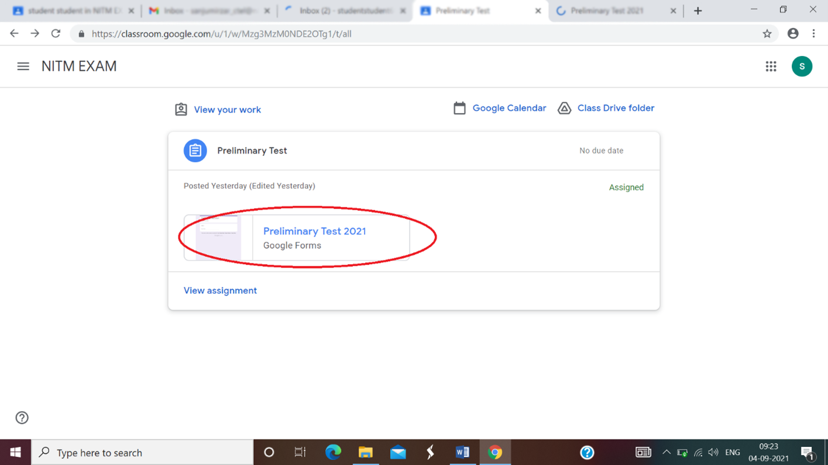

Step 8 : The first page consists of Important Instructions for the Candidates for Preliminary Test / Exam. Please provide the valid Gmail ID provided to NIT Meghalaya. Click on the Next tab at the bottom of the page as shown by the red colored circle in the image below. This will navigate you to the next page of the Preliminary Test /Exam.
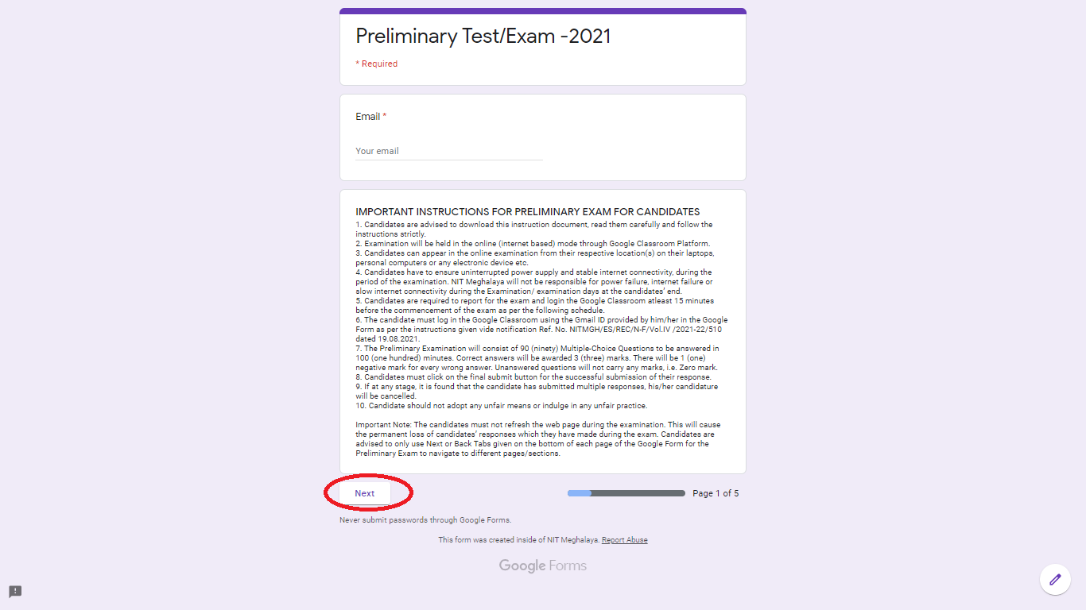

Step 9 : On the second page, Candidate has to provide his/her personal details such as Name, Roll number, Application ID and Category. Click on the Next tab at the bottom of this page to the next page of the Preliminary Test / Exam.
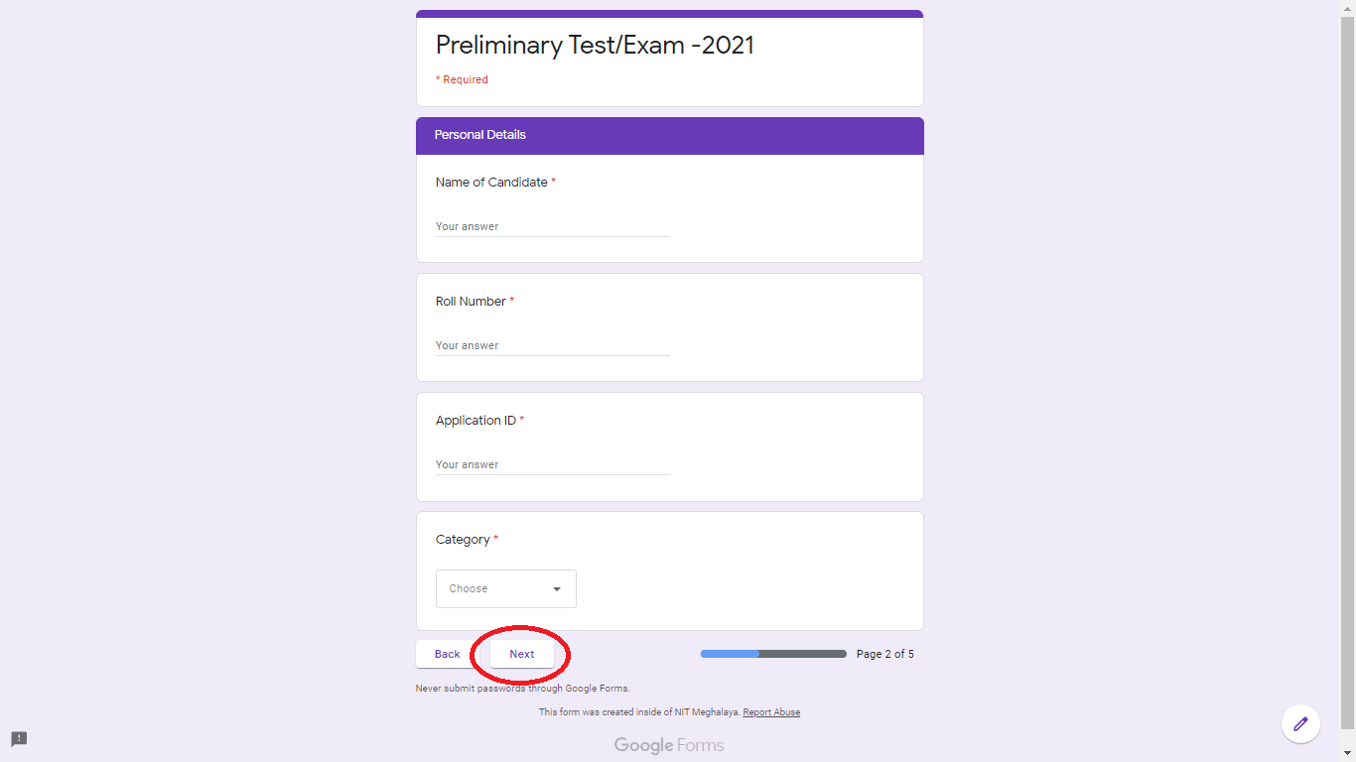

Step 10 : On the third page (Section A), Candidate has to answer 45 MCQ questions (i.e., from Question 1 to Question 45) based on branch/department syllabus for the Preliminary Test / Exam. Candidate may answer by clicking on one of the four options A, B, C and D, as shown in the image below. Scroll up and down to see the entire questions in this page/section. Click on the Next tab at the bottom of this page to the next page/section of the Preliminary Test / Exam.
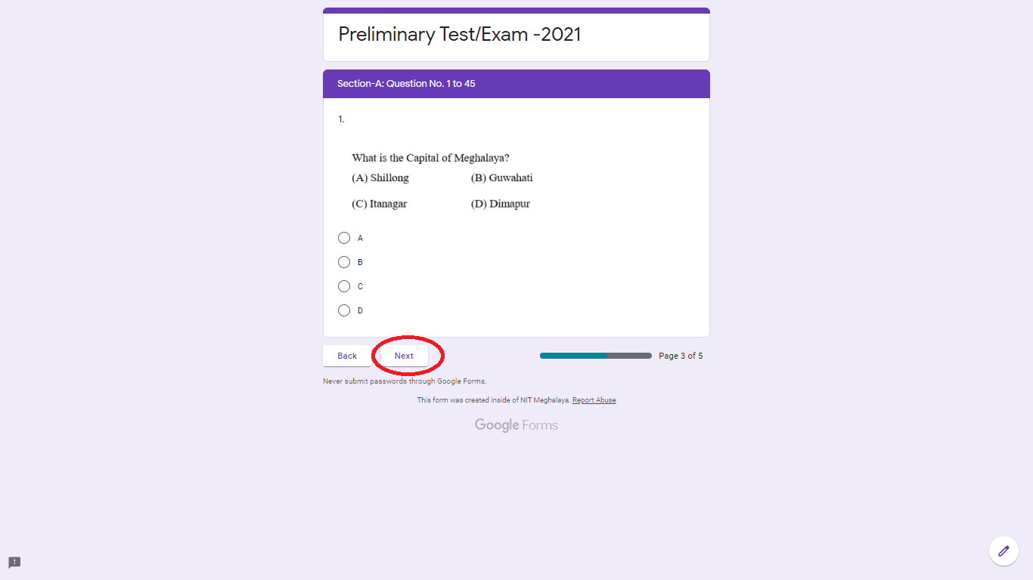
Step 11 : On the fourth page (Section B), Candidate has to answer 15 MCQ questions (from Question 46 to Question 60) based on General Science & Arithmetic syllabus for the Preliminary Test / Exam. Candidate may answer by clicking on one of the four options A, B, C and D. Click on the Next tab at the bottom of this page to the next page of the Preliminary Test/Exam.
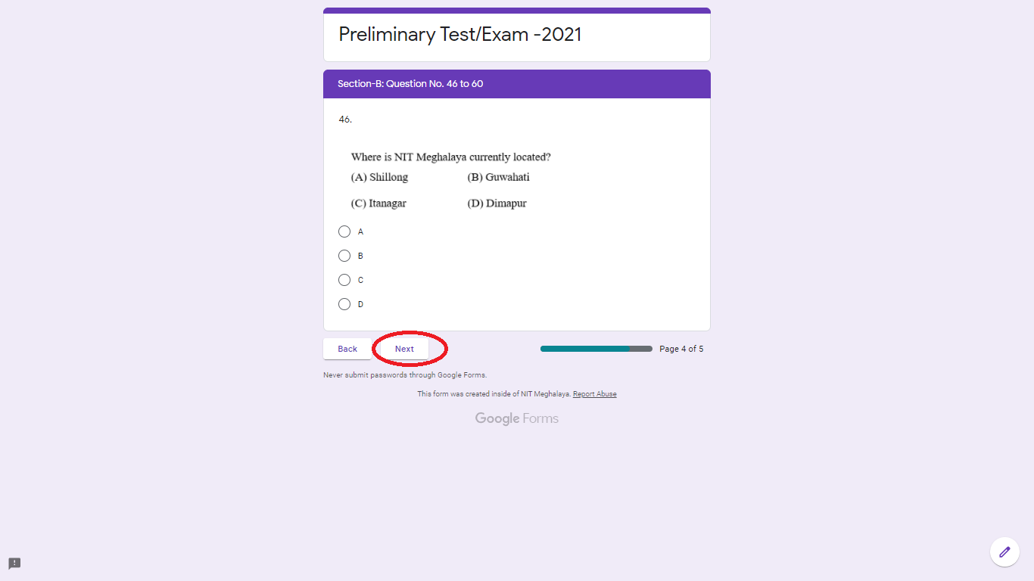

Step 12 : On the fifth page (Section C), Candidate has to answer 30 MCQ questions (from Question 61 to Question 90) based on General English, Logical Reasoning, Computer Application, General Knowledge & Current Affairs for the Preliminary Test/Exam. Candidate may answer by clicking on one of the four options A, B, C and D.
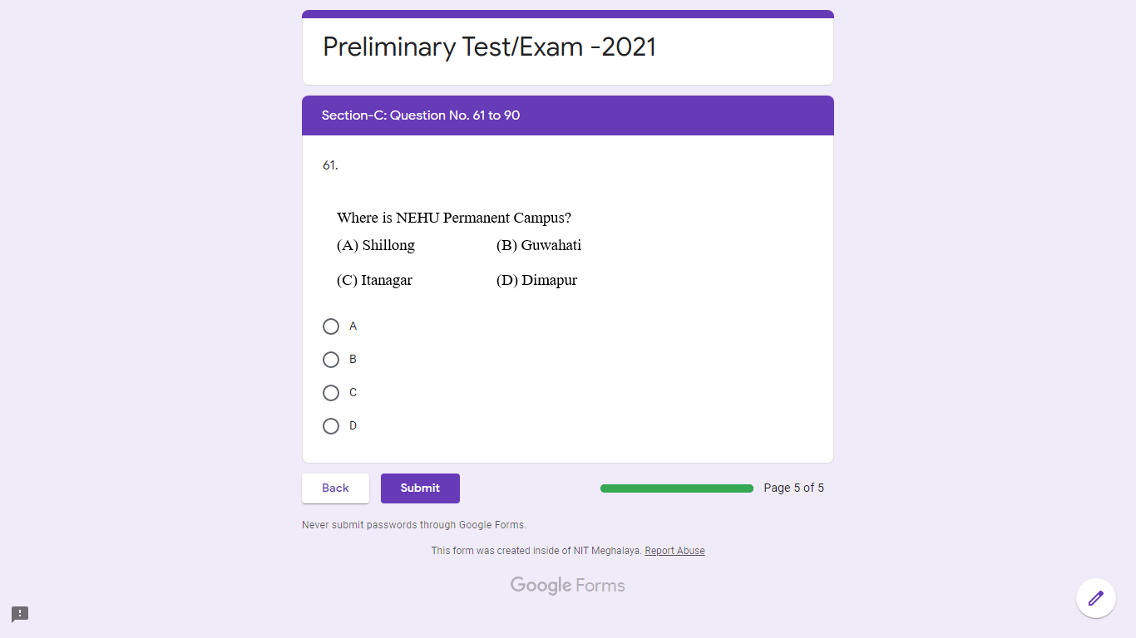

Step 13: Candidate MUST click on the SUBMIT tab at the bottom of this page for final submission of his/her response. The candidate will not be able to edit anything after submitting his/her final response by clicking on the Submit tab. This step is mandatory for successful submission of the candidates’ response to the Preliminary Test/Exam.
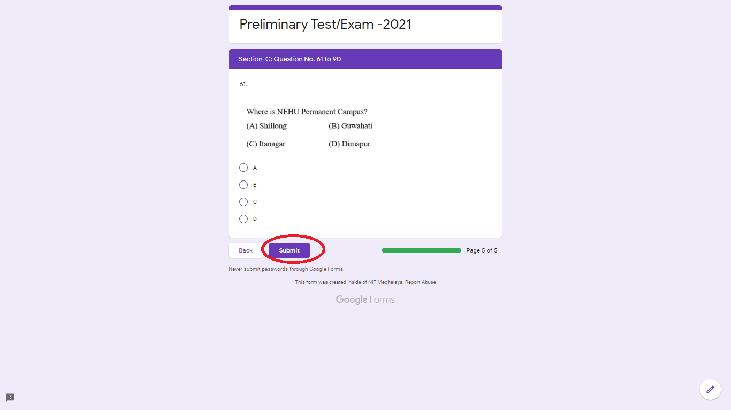

Step 14 : After clicking the Submit tab, the message “Your response has been submitted successfully” will be displayed on the Candidates’ screen.




